**Project Design Phase-II**

**Data Flow Diagram & User Stories**

|  |  |
| --- | --- |
| Date | 20 October 2023 |
| Team ID | 65E0353633A52479B794D3E79D1542E1 |
| Project Name | DATA DOMINATORS: A COMPARATIVE STUDY OF TOP GLOBAL UNIVERSITIES IN DATA ANALYTICS |
| Maximum Marks | 4 Marks |

**Data Flow Diagrams:**

A Data Flow Diagram (DFD) is a traditional visual representation of the information flows within a system. A neat and clear DFD can depict the right amount of the system requirement graphically. It shows how data enters and leaves the system, what changes the information, and where data is stored.

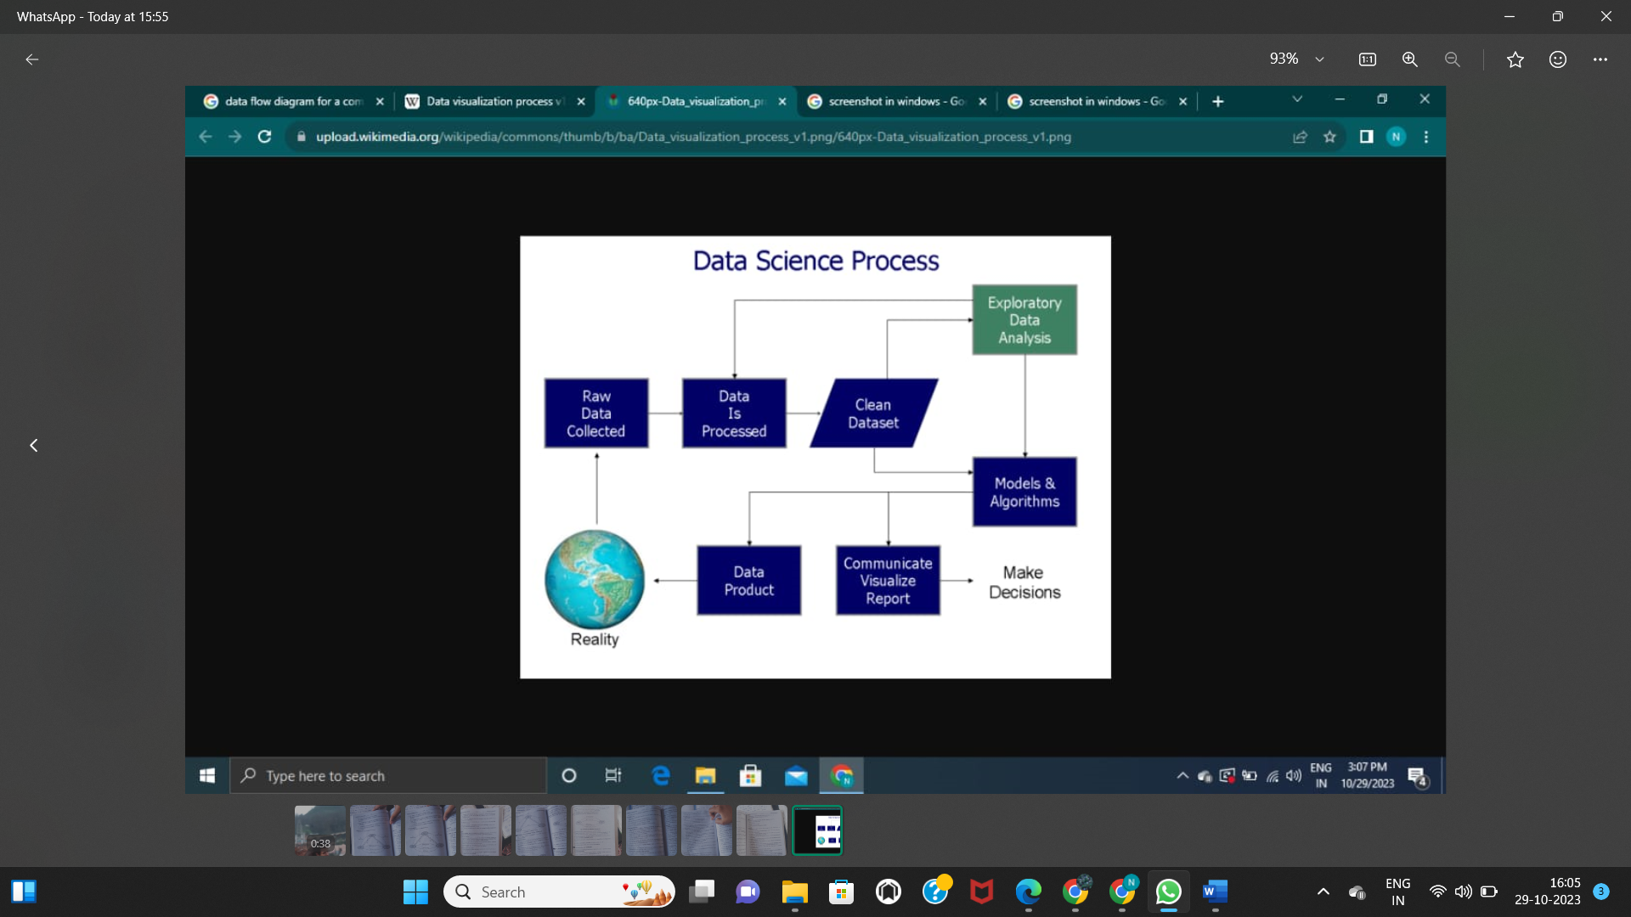

**User Stories**

|  |  |  |  |  |  |
| --- | --- | --- | --- | --- | --- |
| **User Type** | **Functional**  **Requirement (Epic)** | **User Story**  **Number** | **User Story / Task** | **Acceptance criteria** | **Priority** |
| Data analyst | Data visualization | USN-1 | He made visualizations within the given data sets | Accessing to the datasets | High |
|  |  | USN-2 | He/she concludes a decision for increasing customer expectation by giving ideas. | Make reports, dashboards | High |
|  |  | USN-3 | Uses modelling techniques for better user experience | Make decisions and problem solving | High |
| User | Webpage | USN-1 | May come to know about the top universities | May choose those universities | high |
|  |  | USN-2 | Compare the rankings of top universities done by various magazines | Knows the top universities | Medium |
|  | User id | USN-1 | Given access to make comparison between the universities | Accessing the vizualisations | Medium |
|  |  | USN-2 | Can make his own visualizations | Create his own visualizations | Low |